# Lab: First Steps in Coding

Problems for exercise and homework for the "**Programming Basics**" course [@ SoftUni Global](https://softuni.org).

Submit your solutions in the SoftUni Judge system at: <https://judge.softuni.org/Contests/Compete/Index/3540>

## Console Program "Hello SoftUni"

Write a **Java** console program that prints the text "Hello SoftUni".

### Hints and Guidelines

1. Start **IntelliJ IDEA**
2. Create a new project: **New Project**

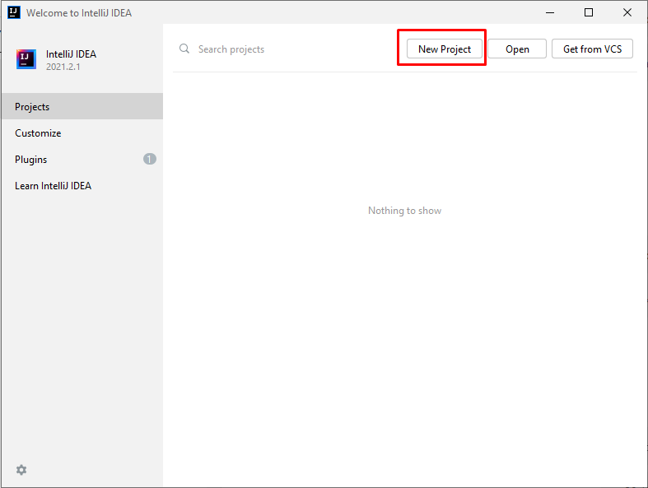

1. Select **Java** project and proceed:

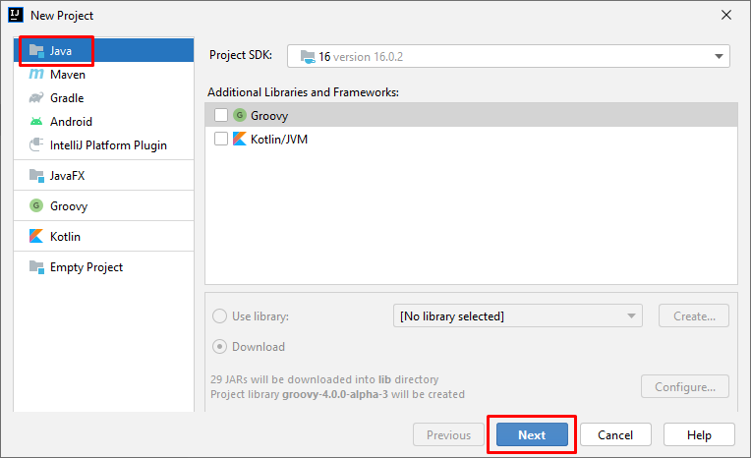

1. Select "**Create project from template**":

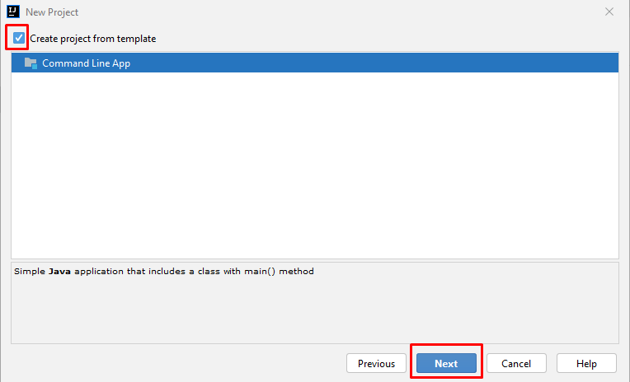

1. Enter an appropriate project name and select a directory in which to be created:

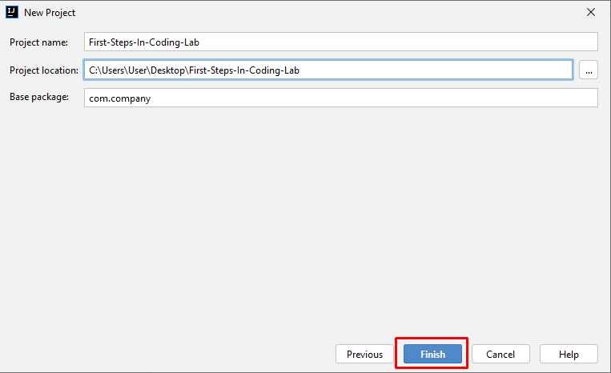

1. Find the main(String[] args) section. Inside it, we write program code(commands) in **Java** language.
2. Write the following program code (command to print the text **"**Hello SoftUni**"**):

|  |
| --- |
| System.out.println("Hello SoftUni"); |

The program code is written offset in one tab relative to the opening parenthesis {.

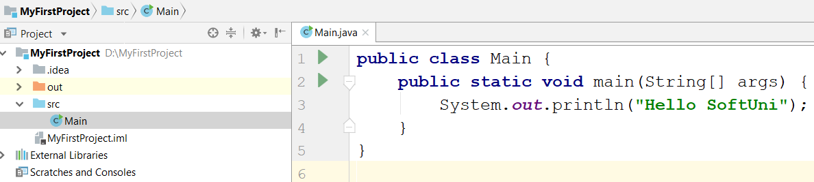

1. Start the program by pressing **[Ctrl+Shift+F10]**. You should get the following result:

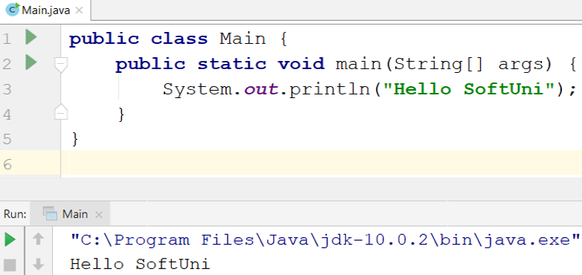

1. **Test** the solution to this problem in the online Judge system of SoftUni. To do this, open: <https://judge.softuni.org/Contests/Compete/Index/3540#0>. Test the solution to this problem in the online judge system of SoftUni. To do this, open it first. Log in with your SoftUni username. A window for submitting solutions for the "**Hello SoftUni**" task will appear. Copy the entire source code from IntelliJ and paste it into the solution submission box:

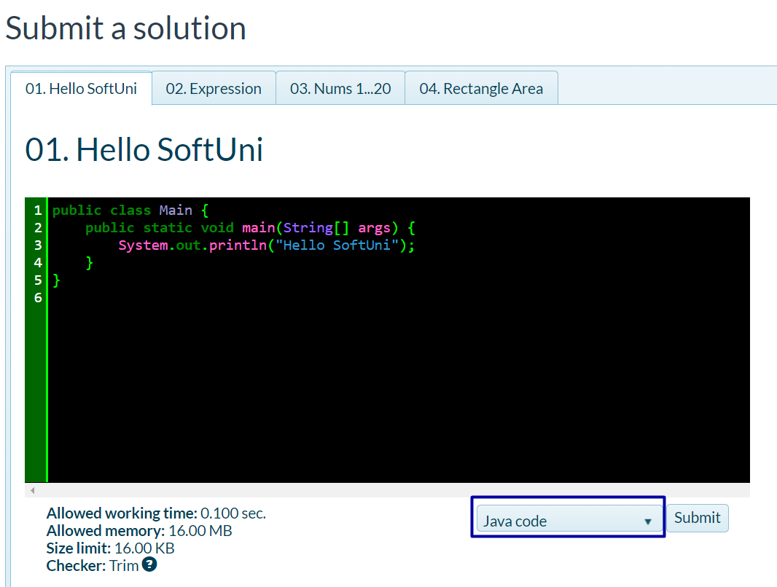

1. Press the **"Submit"** button.
2. The result will appear in the window below. To see it, press the "**Refresh**" button:

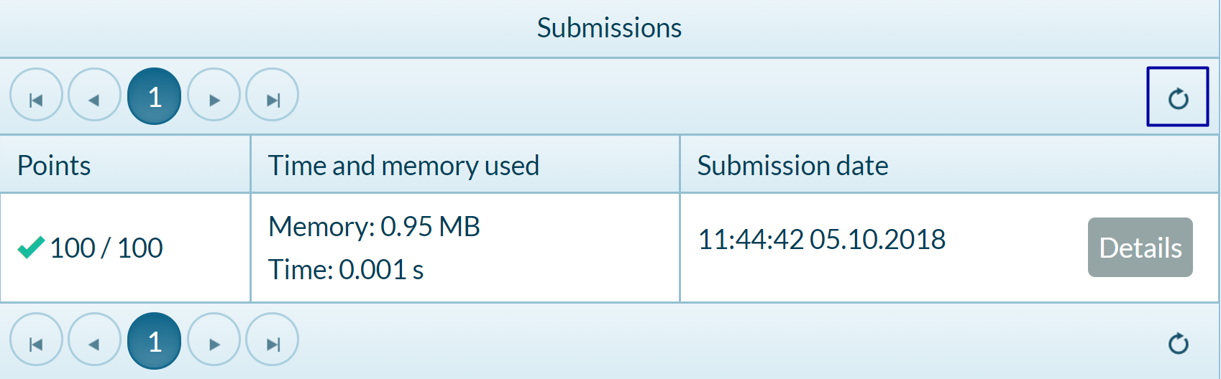

## Nums 1...10

Write a Java console program that prints the numbers **1** through **10** on separate lines on the console.

### Hints and Guidelines

1. Create a new Java class named "Nums1To10" (right-click on the "**src**" folder 🡺 New 🡺 Java Class):

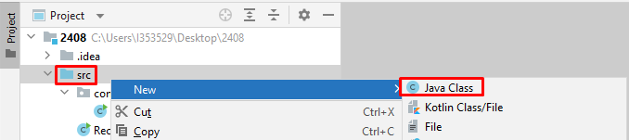

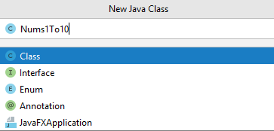

1. Write your **main** method.
2. Type 10 commands System.out.println(); one after another to print the numbers from 1 to 10:

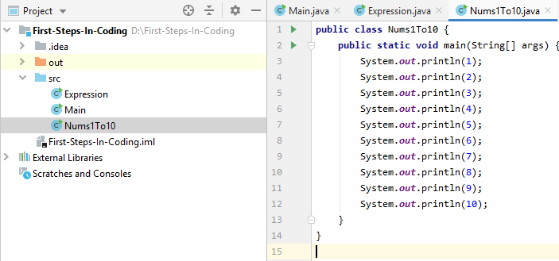

### Testing in the Judge System

Test the solution to this problem here: <https://judge.softuni.org/Contests/Compete/Index/3540#1>

## Rectangle Area

### Write a Java program that calculates and prints the area of a rectangle with predefined sides a and b.

### Sample Input and Output

|  |  |
| --- | --- |
| Input | Output |
| 5  7 | 35 |

|  |  |
| --- | --- |
| Input | Output |
| 6  8 | 48 |

### Hints and Guidelines

1. **Initialize** two variables (a and b) and save the values entered by the console:

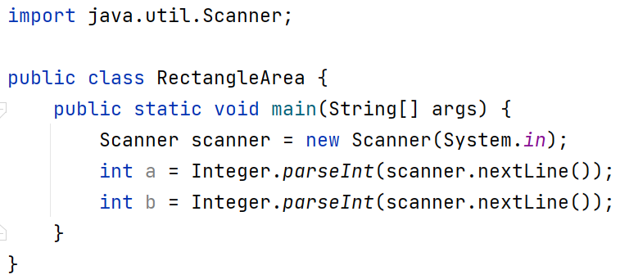

1. **Initialize** a second variable area in which to write the value for the face of the rectangle obtained by the formula **a * b**. Print the result:  
    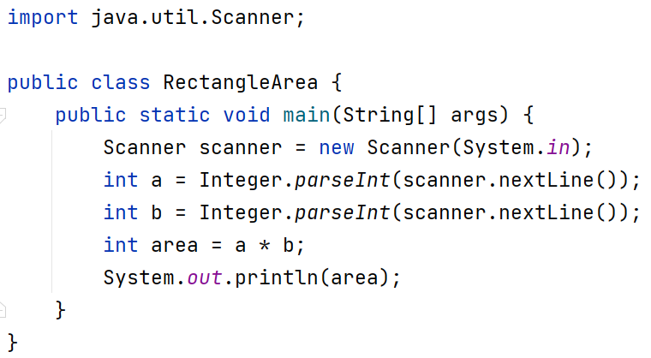

### Testing in the Judge System

Test the solution to this problem here: <https://judge.softuni.org/Contests/Compete/Index/3540#2>

## Inches to Centimeters

### Write a program that reads a floating-point number from the console and converts it from inches to centimeters. To do this, multiply the inches by 2.54 (1 inch = 2.54 centimeters).

### Sample Input and Output

|  |  |
| --- | --- |
| Input | Output |
| 5 | 12.7 |

|  |  |
| --- | --- |
| Input | Output |
| 7 | 17.78 |

### Testing in the Judge System

Test the solution to this problem here: <https://judge.softuni.org/Contests/Compete/Index/3540#3>

**Warning:** It is recommended that you change the settings on your computer to use a **decimal** point:

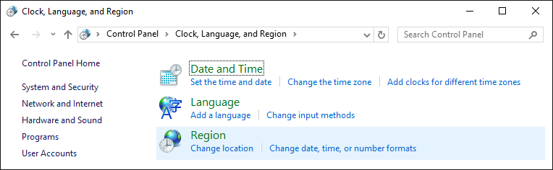

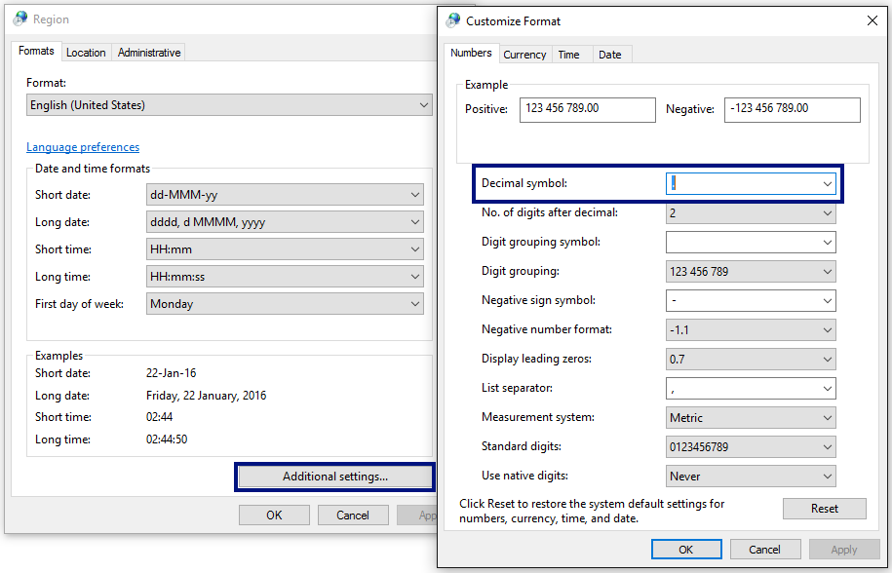

## Greeting by Name

Write a program that reads text (person's name) from the console and prints "Hello, <name>!", where <name> is the name entered from the console.

### Hints and Guidelines

1. First, create a new Java class named "GreetingByName" in the existing project. Right-click on the "**src**" folder in the project and select **New -> Java Class**.



Enter an appropriate name:

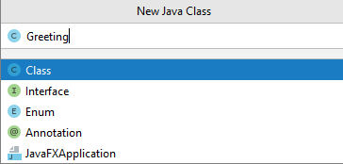

Create a **main** method in the body of the **GreetingByName** class. You can do this by writing the abbreviation **psvm** and pressing the **Tab** button twice:

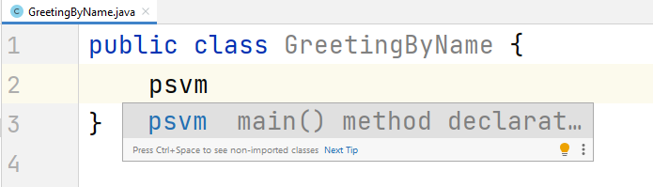

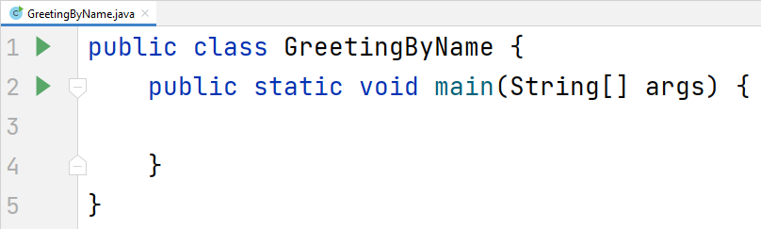

1. To read input from the console, create a **Scanner** object.

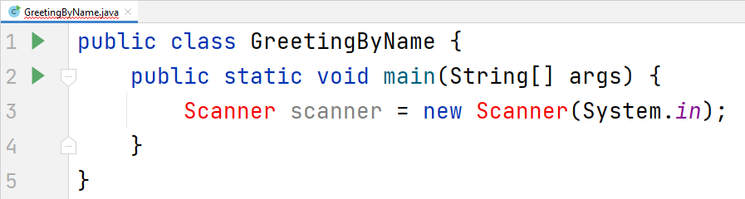

You will notice that the development environment warns us that this object cannot be used yet. To do this, we need to add it from the **Java** development package we have installed (**JDK**). We can do this by typing "**import java.util.Scanner;**" on the first line of the program, or place the cursor on the red text in the field and press **Alt + Enter** and choose **Import Class -> Scanner (java.util)**:

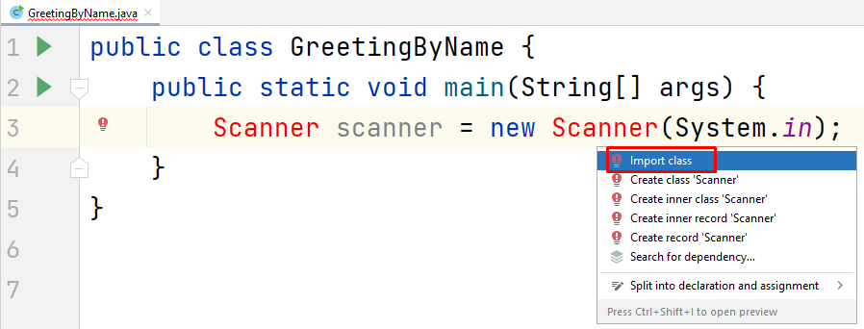

You should get the following result:

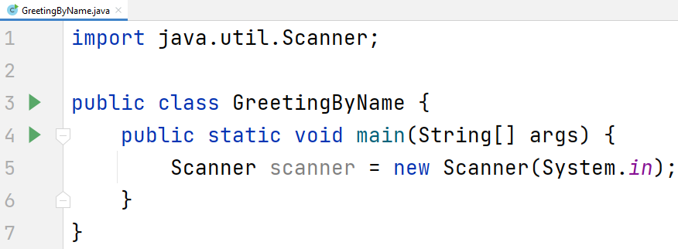

1. Create a **String** variable and save the **name** you get from the console using the **nextLine()** method from the **Scanner** object you created in the previous step:

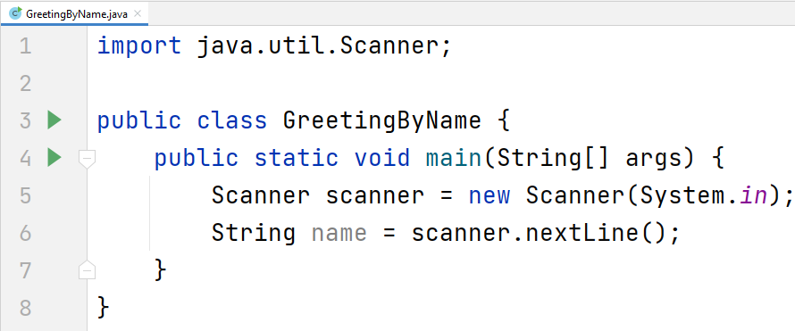

1. Output the console output using the following template:

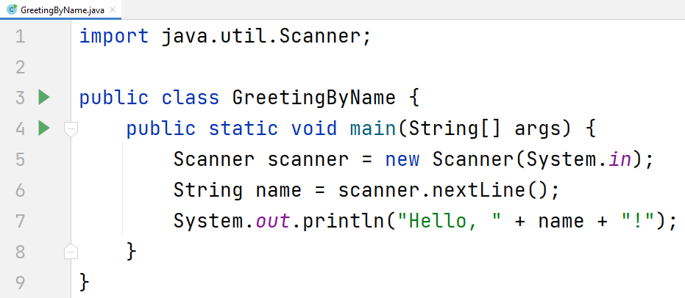

1. Start the program with **Ctrl + Shift + F10** and test with different input examples:

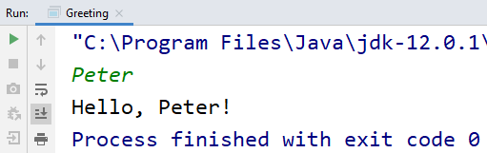

### Testing in the Judge System

Test the solution to this problem here: <https://judge.softuni.org/Contests/Compete/Index/3540#4>

## Concatenate Data

Write a program that reads the name, surname, age, and city from the console and prints the following message: "You are <firstName> <lastName>, a <age>-years old person from <town>."

### Hints and Guidelines

1. Create a new Java class named **ConcatenateData** and the **main** method inside it.
2. Enter the input data and save it in variables with the appropriate data type

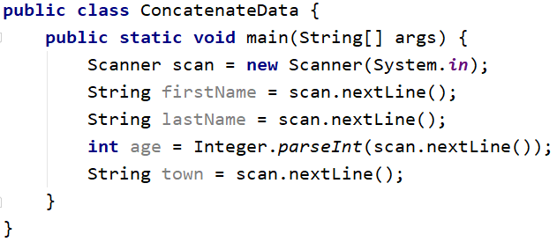

1. Display the formatted **output** on the console:

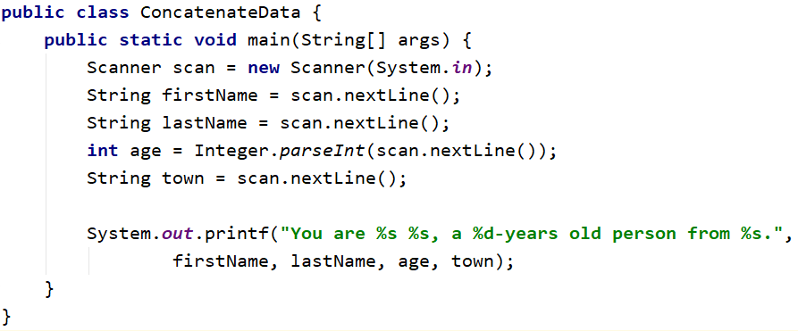

You can achieve the same result with the **concatenation method**:

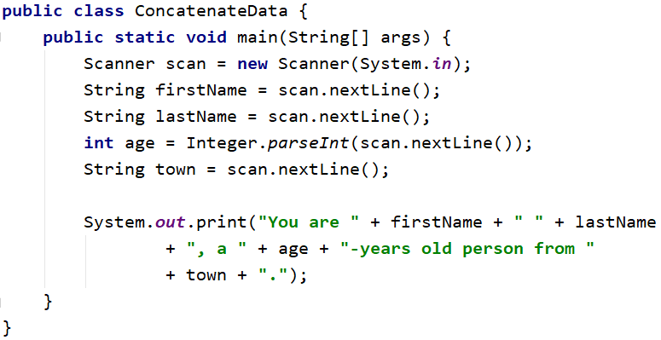

You will notice that the concatenation method has a longer record and creates **preconditions for more errors** compared to the template method.

1. Start the program and test with different input examples.

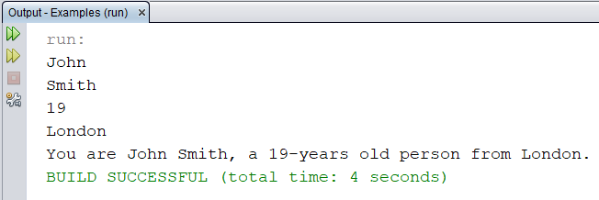

### Testing in the Judge System

Test the solution to this problem here: <https://judge.softuni.org/Contests/Compete/Index/3540#5>

## Projects Creation

Write a program that **calculates how many hours** it will take for an architect to **design several construction projects**. The preparation of a project takes **three hours**.

**Input Data**

2 lines are read from the console:

1. **Name of the architect – string**
2. **Number of projects to be prepared – an integer in the interval [0 … 100]**

**Output Data**

On the console print:

* **"The architect {name of architect} will need {needed time} hours to complete {number of projects} project/s."**

**Sample Input and Output**

|  |  |  |  |  |
| --- | --- | --- | --- | --- |
| **Input** | **Output** |  | **Input** | **Output** |
| George  4 | The architect George will need 12 hours to complete 4 project/s. | John  9 | The architect John will need 27 hours to complete 9 project/s. |

### Testing in the Judge System

Test the solution to this problem here: <https://judge.softuni.org/Contests/Compete/Index/3540#6>

## Pet Shop

Write a program that calculates the **cost of buying dog and cat food**. The food is bought from a pet store, as one package of dog food costs **2.50 USD**, and a package of cat food costs **4 USD**.

**Input Data**

2 lines are read from the console:

1. **Number of packages of dog food - an integer in the range [0… 100]**
2. **Number of packages of cat food - an integer in the range [0… 100]**

**Output Data**

On the console print:

**"{Total sum} USD"**

**Sample Input and Output**

|  |  |  |  |  |
| --- | --- | --- | --- | --- |
| **Input** | **Output** |  | **Input** | **Output** |
| 5  4 | 28.5 USD. | 13  9 | * 1. USD. |

### Testing in the Judge System

Test the solution to this problem here: <https://judge.softuni.org/Contests/Compete/Index/3540#7>

## Yard Greening

Sophia has **several houses** on the Black Sea coast and **wants to green the yards of some of them**, thus creating a **cozy atmosphere and comfort** for its guests. She has hired a company for this purpose.

Write a program that calculates the amount needed for Sophie to pay to the project contractor. The price per square meter is **7.61 USD** including VAT. Because her yard is **quite large**, the contractor company offers an **18% discount on the final price.**

**Input Data**

One line is read from the console:

1. **Square meters of the landscaped – a floating-point number in the range [0.00 … 10000.00]**

**Output Data**

Two lines are printed on the console:

* **"The final price is: {final price of the service} USD."**
* **"The discount is: {discount} USD."**

**Sample Input and Output**

|  |  |  |
| --- | --- | --- |
| **Input** | **Output** | **Comments** |
| **550** | The final price is: 3432.11 USD.  The discount is: 753.39 USD. | We calculate the price for landscaping the whole yard:  **550** * **7.61** = **4185.50** USD.  We deduct the discount (18% = 0.18) of the total:  **0.18** * **4185.5** = **753.39** USD.  We calculate the final price of the service:  **4185.50** – **753.39** 🡪 3432.11 USD. |
| **Input** | **Output** |  |
| 150 | The final price is: 936.03 USD.  The discount is: 205.47 USD. | We calculate the price for landscaping the whole yard:  **150** * **7.61** = **1141.50** USD.  We deduct the discount (18% = 0.18) of the total:  **0.18** * **1141.50** = **205.47** USD.  We calculate the final price of the service:  **1141.50** – **205.47** 🡪 936.03 USD. |

### Testing in the Judge System

Test the solution to this problem here: <https://judge.softuni.org/Contests/Compete/Index/3540#8>